Project Name: Car Rental System

Documentation On

**“Car Rental System”**

**Guided By:** Tarun Rathore

**Submitted By :**

Amit Saini

Pawan Singh Chouhan

Table of Contents

1. Introduction..........................................................................................................................

1.1 Document Purpose............................................................................................................

1.2 Project Background..........................................................................................................

1.3 Aim & Objectives.............................................................................................................

2. Business Requirements Overview…………………………………………………………

3.Functional Requirements......................................................................................................

4. Non-Functional Requirement………………………………………………………………

5. Use Case Diagram................................................................................................................

5.1 Car owner..........................................................................................................................

5.2 User.................................................................................................................................

6. database

1 username...................................................................................................................................

2 car name..................................................................................................................................

3 rent details……………………………………………………………………………………

7. E-R Diagram………………………………………………………………………………………

8. Conclusion

List of Figures

Use Case Diagrams……………………………………………………………………………….

Fig 1 Car-detailsr……………………………………………………………………………………

Fig 2 User…………………………………………………………………………………………

Fig 4 ER Diagram…………………………………………………………………………………

**1. Introduction**

1.1 Document Purpose

This document serves as the Software Requirements Specification (SRS) and Business Requirements Specification (BRS) for the Java-based Car Rental System. It outlines the requirements, objectives, and functionality of the system.

1.2 Project Background

The Car Rental System is a console-based application developed in Java. It utilizes ArrayLists for database management and facilitates car rental operations entirely through the console interface.

1.3 Aim & Objectives

The aim of the Car Rental System is to provide a user-friendly platform for renting cars, managing rental bookings, and processing payments. The objectives include:

Implementing functionality for users to rent available cars for a specified duration.

Allowing users to return rented cars after the rental period.

Managing user and car information efficiently using ArrayLists.

Providing a seamless rental experience through the console interface.

**2. Business Requirements Overview**

The Car Rental System caters to both car owners and users seeking to rent cars. It facilitates rental operations, manages user and car data, and ensures smooth transactions.

**3. Functional Requirements**

3.1 Renting a Car

Users can view a list of available cars.

Users can select a car for rent by specifying the car ID.

Users must input their name and rental duration.

The system calculates the total rental price.

Users confirm the rental transaction.

3.2 Returning a Car

Users can return a rented car by specifying the car ID.

The system marks the car as available for rent.

Confirmation of successful car return is displayed.

**4. Non-Functional Requirement**

Input validation ensures accurate user input.

Error handling provides informative messages.

The system operates efficiently within a console environment.

User interactions are intuitive and straightforward.

**5. Use Case Diagram**

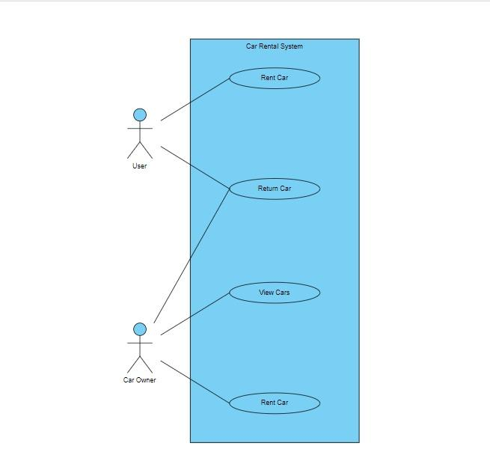

**6. Database**

User Name: Stores user information.

Car Name: Stores information about cars available for rent.

Rent Details: Stores rental transaction information.

**7. E-R Diagram**

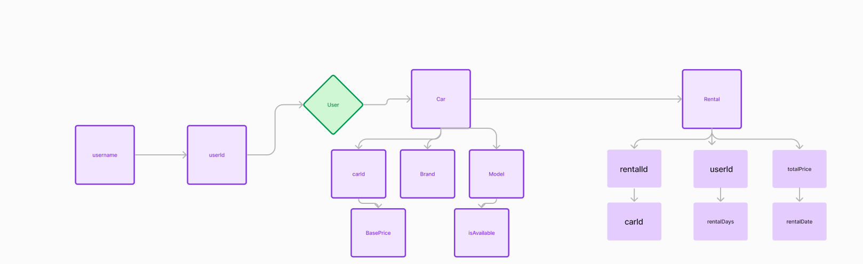

**8. Conclusion**

The Car Rental System offers a convenient solution for users to rent cars and manage rental bookings efficiently. It meets the specified requirements and objectives, providing a seamless rental experience through the console interface.

Please note that detailed diagrams, tables, and additional explanations can be included based on project specifications and stakeholder requirements.